Russia, Nizhniy Novgorod, 40-yeas of Victory str., 17.  Phone. +7(831) 463 23 08  Cell. +7 908 159 14 07  tam-levkoeva@yandex.ru.ru | Wooden containers/boxes and packing
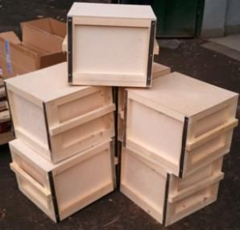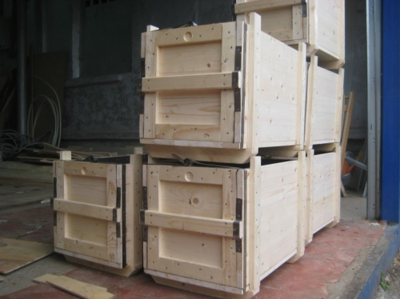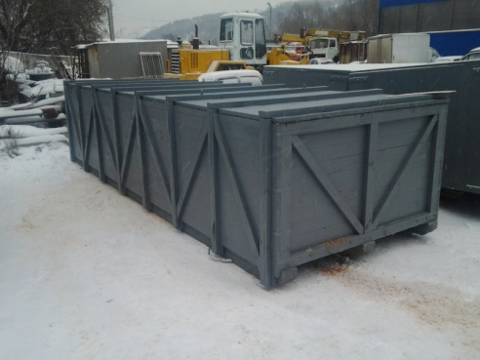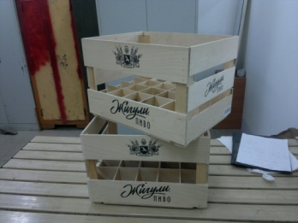
Our company, Altair LLC, has been working on the market since 2008.
Key business line of Altair LLC is manufacturing wooden packing. Our productions facilities allow us to make high-quality products; our specialists are ready to arrange manufacturing of new product within the shortest possible period of time
All our products are made on the modern equipment by highly qualified specialists, which guarantees high quality and reliability rate of our goods
Small prices of our products are determined by close location of raw materials.
Altair Company also produces tare blanks for companies with their own assembly production
Our enterprise is able to make wooden packing according the order of the customer.
You can order development of original project; or present us the following documentation for further work:
- layouts of wooden containers/tare/boxes;
- drafts of wooden containers/tare/boxes;
- design drawings for production of wooden containers/tare/boxes;
- technical requirements for production of wooden containers/tare/boxes;
- Layouts of the goods which you want to pack.

Altair Company also produces tare blanks for companies with their own assembly.
Our wooden packing is produced in accordance with requirements of international standard ISPM 15, and made of timber, passed through thermal treatment (fumigation), which is proved by all necessary documentation and has special mark on packing.

One more important business line of our enterprise is manufacturing of cable reels and drums for storage and transportation of wires and cables. These products are made on basis of technical requirements of the customer.

We hope that above mentioned information is useful for you and look forward to your reply for further negotiations
If any question occurs, don’t hesitate to contact us.
We are always ready for future cooperation

Sincerely yours,
Tamara Levkoeva,
Phone. +7(831) 463 23 08
Cell. +7 908 159 14 07
tam-levkoeva@yandex.ru.

