JSC SEZ “Lipetsk”  Russia, 398908, Lipetsk  Special Economic Zone Area  SEZ Business Centre  tel.: + 7 (4742) 51-51-80  fax: + 7 (4742) 51-53-95 info@sez.lipetsk.ru  learn more about us on  www.sezlipetsk.ru and www.russez.ru |  |  | _____________________  _____________________  _____________________

Dear …………!

Lipetsk Industrial Special Economic Zone is pleased to submit for your attention a proposal on experiencing new advantages of growth in Russia.
Representing one of the top production parks in the country, we believe Lipetsk SEZ may offer _____________unique expansion opportunities. Here is a quick overview of the proposal content:
Investor Perspective
Manufacturing companies seeking to get closer to their customers on the promising markets get the chance to set up a new production site within months due to the transparent and well-paved patterns the SEZ offers, including:
- state-run, ready-to-use infrastructure with all utilities in place,
- Free Customs Zone / tax holidays,
- lowest land costs ever(!),
- non-existent red tape / simplified paperwork.
Industry Perspective
___________are/is top economy sector(s0 in Lipetsk - a region in the centre of European part of Russia. Investments into ______________ have been growing drastically over the last decade. Owing to this, the market demands for the ______________far outrun the supply available.

Proposal on the Next Steps:
We are at your disposal if you choose to explore the SEZ potential further with regard to your company expansion. Your team may pick up any form of investigation:
- on-line tele- and video conferencing at any time convenient.
- remote mode of tailored feasibility studies preparation together with our IR-department specialists .
- a visit from an initial _____________research group on-location at any time convenient.
Contacts: invest@sez.lipetsk.ru

Benefits of setting up a new facility in Lipetsk SEZ:
- Exceptional Costs Cuts on establishing a new factory,
- Proven track record with over 45 companies from across the globe including world-wide industry leaders,
- Federal Government support and safeguards.

Many thanks on the opportunity to introduce the project to you. We are certain that we can grow our first contacts into a conspicuously successful partnership.
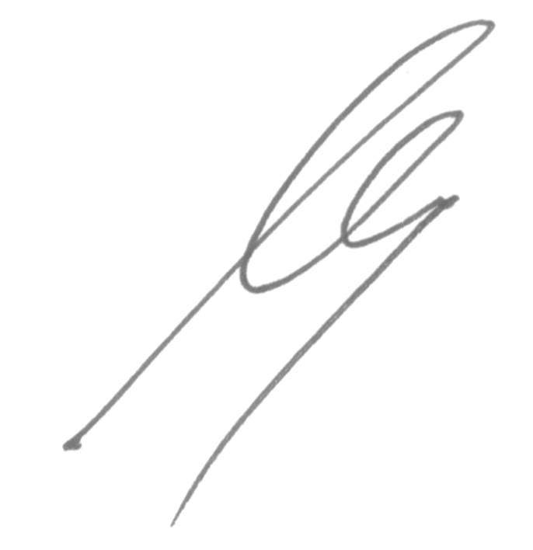
Sincerely,
Director General I. Koshelev

