俄罗斯技术：

高速高压防锈研磨清整设备“TARI”

RUSSIAN “TARI” APPARATUSES FOR A HIGH-SPEED

ABRASIVE CLEANING OF SURFACES

Today huge quantities of metal, concrete, stones and other materials are used in industry, construction and power engineering. The destructive affects of the environment and technogenic factors reduce considerably the service life of buildings, constructions, machines and equipment, pollute their surfaces and cause their premature destruction (Fig. 1 and 2).
Annually corrosion "eats up" over 10 % of all the metal, produced in the world!

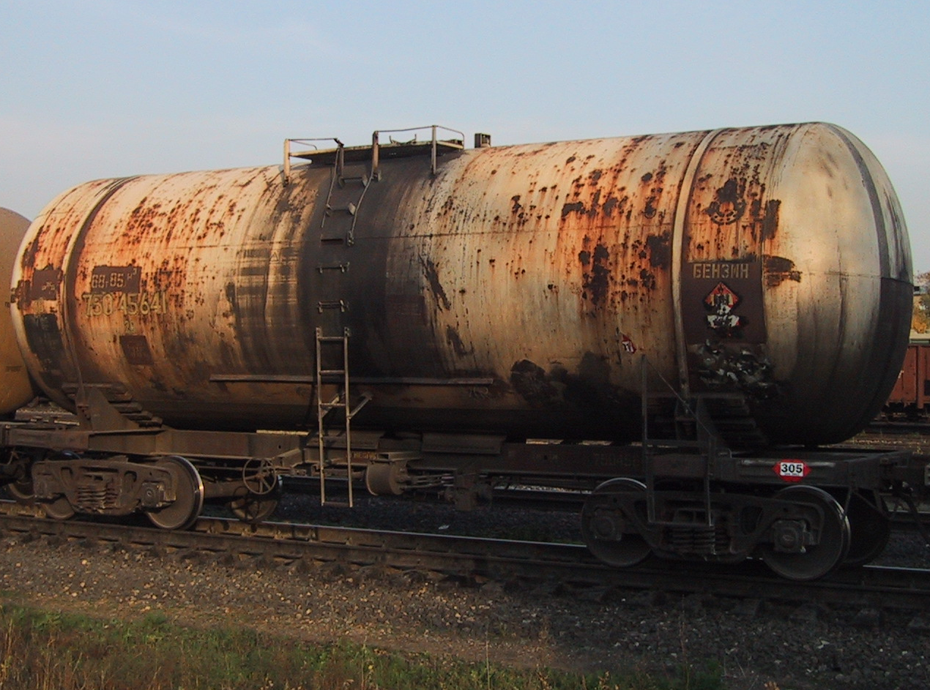

Fig.1. A tank car before cleaning.

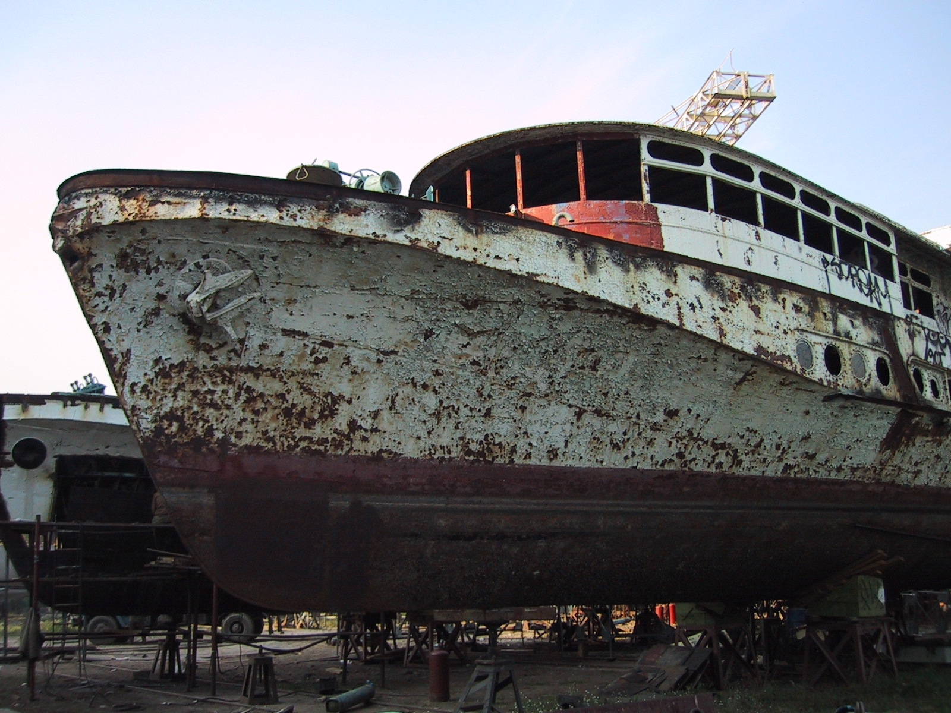

Fig.2. A ship's bottom prepared for cleaning.

We have developed shot blasting machines of TARI family for an effective abrasive cleaning of various metal and nonmetal surfaces (removal of rust, old paint, atmospheric and oil pollution, etc.). The machines can have different productivity, be mobile (Fig. 3) or stationary.
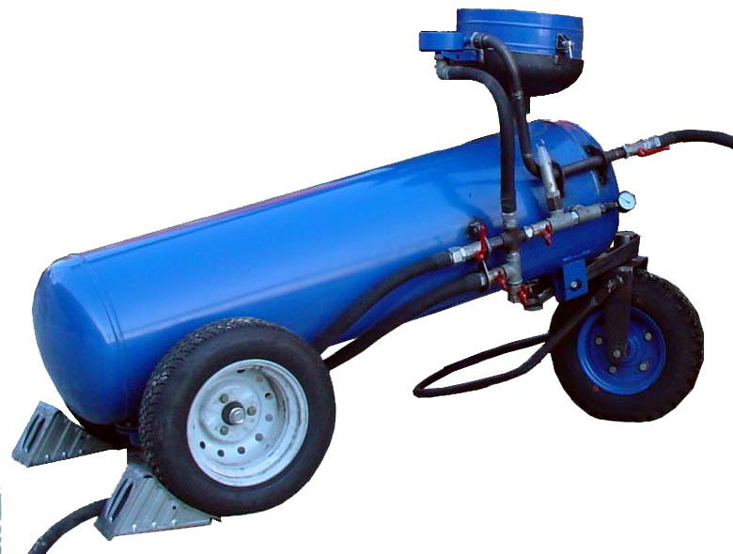

Fig. 3. Shot blasting machine TARI – 250.

Since the working speed of the abrasive corpuscles in TARI apparatuses (and, consequently, their kinetic energy) exceeds the parameters of their world analogs in several times, the apparatuses have a substantially higher productivity.
The processed surface is 100 % ready for a subsequent drawing of protective coatings, is characterized by uniformity, absence of pollution and dust, and meets the standards of ISO 85011.1988.
Fig.4. Schematic diagram of TARI installation:

1- trunk; 2- feeder; 3- vessel; 4- activator; 5- abrasive sleeve; 6- connecting collet; 7, 9, 11, 16 – globe valve; 8 - mixing faucet; 10 - pneumoreceiver; 12 - back valve; 13 - crosspiece; 14-loading hopper; 15 - rod; 16 – supply manifold; 17 - protective insert; 18 - protection sleeve; 19 - manometer of pressure in the vessel; 20 – wheel.

Fig. 4 presents a schematic diagram of operation of TARI apparatuses. Conic trunk (1) is connected to a vessel (3) by an abrasive-resistant sleeve (5). A force feeder includes a feeder (2), a loading hopper (14) with a sieve and a protecting cap, a self-controlled feeding system (2, 4, 17, 18) with two vacuum cleaners-ejectors and a gate. The feeder (2) consists of a three-dimensional vibration exciter, an activator (4), an acoustical broadband oscillator, ring ejector, a mixing faucet and a moisture separator with a hydraulic gate.

Our research work showed that only a small part (3-5 %) of the compressed air is used for dispersal of the abrasive corpuscles, therefore productivity of cleaning in traditional apparatuses is 8-30 m²/hour, and the discharge of an abrasive is 40-70 kg/ m².
TARI apparatuses essentially increase the kinetic energy of the abrasive corpuscles, due to their optimum ratio reduce the discharge of the working components (abrasive material and air) in several times, and, hence, and the cost of the processing is also lower. The apparatuses ensure a good roughness (up to R_{Z} <94.7 microns) and high uniformity of the processed surface.
Possibility of processing of surfaces under various angles and application of special trunks (with length up to 1900 mm) practically exclude traumas of a operator (Fig.5).

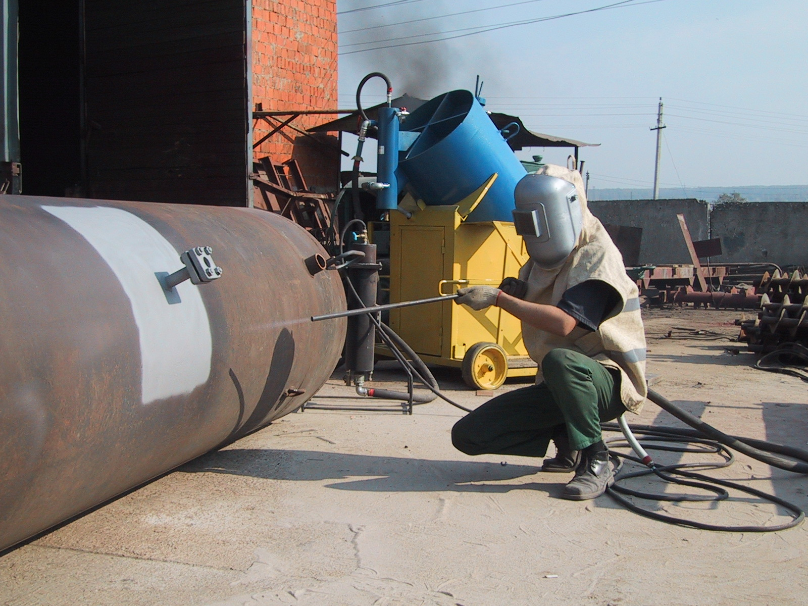

Fig.5 High-efficiency cleaning of a tank.
Surface smoothness Sa = 3 according to ISO 8501.

In development of TARI apparatuses a lot of attention was devoted to the questions of improvement of the service life of their design elements, which ensure feeding and transportation of an abrasive. The design solutions realized in the apparatuses allow to exclude application of metal wearing feeders. Besides, the working bore of the trunk is protected by inserts made from a diamond like material, which prolongs its service life many times.

The produced TARI apparatuses vary by their productivity for processing surfaces from 35 up to 110 m²/h (Table 1).

Таble 1

Main characteristics of TARI apparatuses
Volume of a feeder, l | TARI 50 | TARI  250 | TARI  500 | TARI  1000 | TARI  1350 | TARI  2000 | TARI  4000
Productivity, m²/h | 35 | 60 | 105 | 95 | 100 | 105 | 110
Air pressure, МPа | 0.3-1.2 | 0.3-1.2 | 0.3-1.2 | 0.3-1.2 | 0.3-1.2 | 0.3-1.2 | 0.3-1.2
Caliber of the trunk, mm | 6-9 | 12-16 | 14-18 | 14-20 | 14-20 | 14-20 | 16-22
Air discharge, m³/min | 2,8 | 10 | 12 | 15 | 15 | 15 | 18
Discharge of an abrasive, kg/m² | 12 | 10 | 9 | 9 | 9 | 9 | 9
Weight in assembly, kg | 47 | 260 | 450 | 820 | 1050 | 1270 | 1850

Comparative characteristics of the shot-blasters most popular in Europe and TARI apparatuses are presented in Table 2.

Таble 2
№ | Characteristics | Units of measurement | Shot-blasters, most popular in Europe
№ | Characteristics | Units of measurement | DSG-160  (Russia) | Klemko  (Germany) | Puhti  (Finland) | TARI
1. | Volume of a feeder | l | 160 | 200 | 150 | 27-1350
2. | Productivity | m²/h | 8 | 17 | 14 | 30-60
3. | Working air pressure | МPа | 0.7 | 1.0 | 1.0 | 0.8
4. | Discharge of an abrasive | kg/m² | 50-80 | 40-50 | 40-60 | 10-14
5. | Air discharge | m³/min | 9 | 18 | 12 | 2.2-15
6. | Surface smoothness (surface roughness R_{Z}) | micron | 25 | 60 | 50 | 94.7

Apparatuses of TARI series are widely applied in Russia for rust-proofing of the bodies of cars, pipelines, tanks, bridges, etc.

Contacts in China (Beijing):

Trade Representation of Russia in China (Russian Embassy)
Phone (010) 65322201
Fax (010) 65325398
E-mail: russchinatrade@gmail.com

合作方式：在中国代理销售。

联系方式：
俄罗斯驻华商务代表处业务部门
北京电话： (010) 65322201 传真: (010) 65325398
电子邮箱：russchinatrade@gmail.com
网站：www.russchinatrade.ru

